SeaChange Service Shell Template User Guide Ver0.1

Precondition
- OS environment
Windows 2000

- Source Code
Zqprojs/common/BaseSchangeServiceApplication.cpp
Zqprojs/common/BaseSchangeServiceApplication.h
Zqprojs/common/SchangeServiceAppMain.cpp

- Compile environment
Preprocess Definition
Because of the compile mode of SeaChange SDK API, the preprocess definition of the kernel project you are about to packet with SeaChange Service Application Shell must be set as following setting.
_UNICODE UNICODE _AFXDLL

Precompile Head
You should not use precompiled head or use the option automatic use of precompiled headers.

- Log writer
The template initialized a log writer named ScReporter which packed SeaChange reporter. So the kernel you implemented should use ScReporter as its log writer at first. ScReporter is inherited from ZQ::common::Log , so you can write your log by ZQ::commom::Log in your kernel. And when implementing the template, set the point of log writer as the instance of ScReporter template initialized.

Implement
Write a Class inherited from Class BaseSchangeServiceApp. This Class must implement the virtual function in the base class. And the min set of functions you should implement are Oninit(), OnStart(), OnStop(),OnUnInit().You shall implement the life cycle in these function.

Setup and Configuration
PLS Preference :VODSoftwareInstall&ConfigGuide.v01.8.pdf
This file is in the doc directory of ITV SDK.
The configurations template will read as default are as following.
The path of register: HKEY_LOCAL_MACHINE\SOFTWARE\SeaChange\<product name>\
CurrentVersion\Services\<service name>\
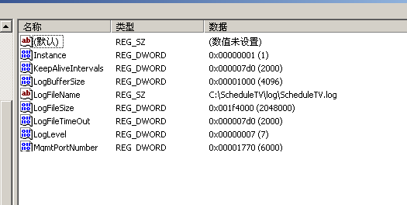
Note: MgmtPortNumber is for Manutil and must be exclusive.

Debug
VC6.0 Program argument -s [ServiceName] [ProductName]
VC7.0 Program argument -s [ServiceName] [ProductName]
Sample –s ISAUpload ITV
HKEY_LOCAL_MACHINE\SOFTWARE\SeaChange\ ITV \
CurrentVersion\Services\ ISAUpload \
You can set your configurations in this path.
And read them by calling the function getConfigValue().

